Table of Contents
1. How do I set up and install my router? 1
2. How do I change the Administrator password on my router? 11
3. I have forgotten my wireless password, how do I recover it? 13
4. How do I change the IP Address of my router? 15
5. How do I change the 802.11 mode on my router? 16
6. How do I change the channel on my router? 18
7. How do I change the SSID/network name of my router? 21
8. How do I enable WEP encryption so my older devices can connect? 23
9. How do I change the Wi-Fi Password on my router? 25
10. How do I reset my router to factory default settings? 27
11. How do I set up Website Filtering on my router? 28
12. How do I upgrade the firmware on my router? 30
13. How do I back up the router’s configuration to my computer? 32
14. How do I configure QoS (Quality of Service) settings on my router? 34
15. How many simultaneous users can my Wi-Fi network handle? 36
16. How do I connect my Wi-Fi enabled computer to my wireless router? 36
17. How do I connect my iPad® to my wireless router? 39
18. How do I connect my iPhone® to my wireless router? 45

How do I set up and install my router?

- Install the USB 3G adapter (optional).

If you wish to use a 3G USB modem as the primary method to access the Internet, plug your 3G USB modem into the USB port on the back of the DWR-113. Skip to part B, step 3.

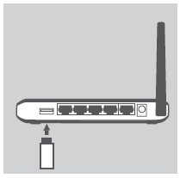

- Connect to the modem

Step 1: Position your DWR-113 near your Internet-connected modem. Keep the router in an open area for better wireless coverage.

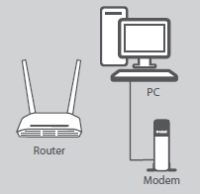
Step 2: Unplug the modem’s Ethernet cable connected to your computer (or existing router) and plug it into the port labeled ‘INTERNET ’ on the back of the router. Connect the supplied power adapter to the router and a power outlet, then verify that the power LED is on.

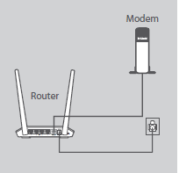
Step 3: Plug one end of the supplied Ethernet cable into the port labeled ‘1’ on the back of the router, and the other end into the Ethernet port on your computer. To set up the DWR-113 using Wi-Fi, go to your computer or mobile device's Wi-Fi settings and select the network name listed on the included Wi-Fi Configuration Note (ex: dlink), then enter Wi-Fi password.
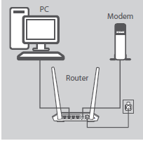

Step 4: Open an Internet browser (such as Internet Explorer®) and http://192.168.0.1 into the address bar. Press Enter.

Step 5: Enter your login information in the fields provided. The default username is Admin. Enter your administrator password. If you have not changed the default password, leave this field blank. Click Login.

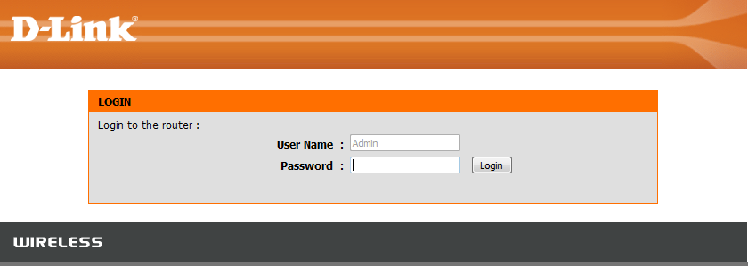

Step 6: Click on the Setup tab at the top of the page, and click Internet from the menu on the left-hand side. Click Manual Internet Connect Setup.

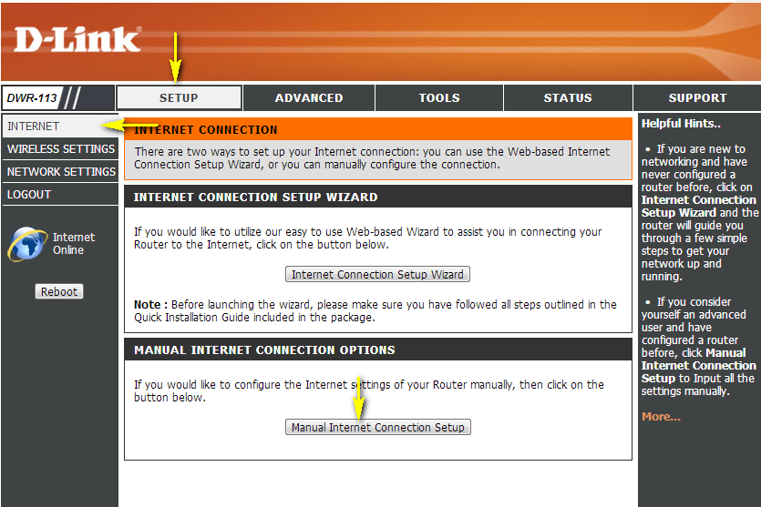
Select the Internet Connection type specified by your Internet Service Provider (ISP). The corresponding settings will be displayed below. Please see the following pages for details on how to configure these different connection types.
Failover Internet Connection is: You can set a secondary Internet connection as a backup for when your primary connection fails. To create a failover rule, click on the Failover Setting… button above. Once enabled, the failover network type will be displayed.

Dynamic IP (DHCP)

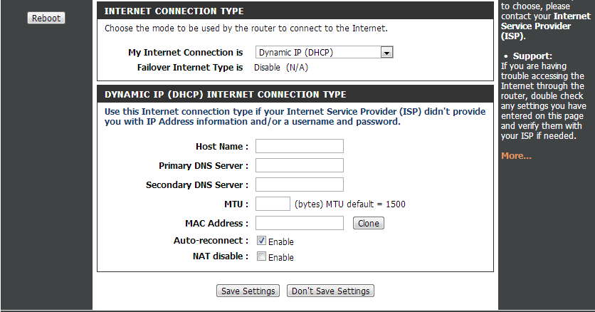

Host Name: If specified by your ISP, enter a host name. Otherwise, this field can be left blank.
Primary DNS Server: Enter the primary DNS server specified by your ISP.
Secondary DNS Server: Enter the secondary DNS server specified by your ISP.
MTU: If instructed to do so by your ISP, set the MTU (If not, the default value is 1500).
MAC Address: The default MAC Address is set to the Internet port’s physical interface MAC address on the Broadband Router. If you wish to specify a MAC address for this device, enter the address in this field, or use the Clone button to copy the MAC address of the network adapter currently being used.
Auto-reconnect: Check this check box to enable auto reconnect.
NAT Disable: Check this box to disable Network Address Translation.

Static IP
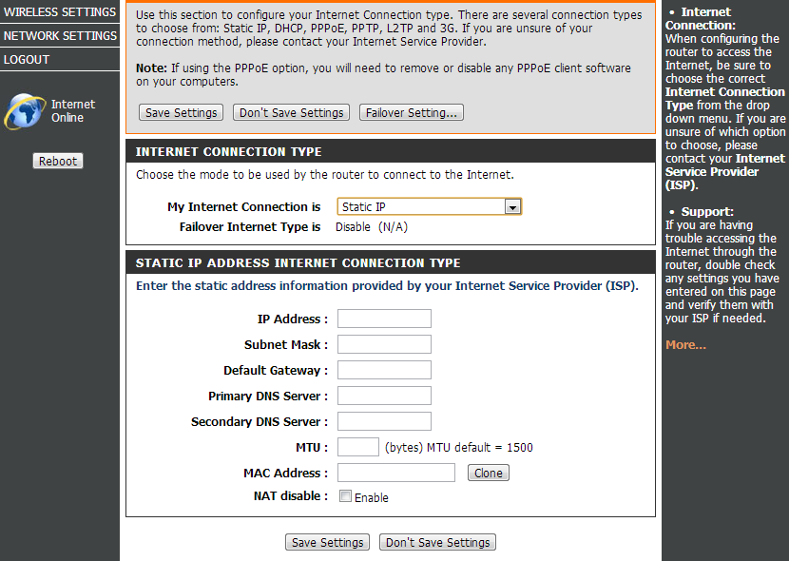
IP Address: Enter the IP address assigned to you by your ISP.
Subnet Mask: Enter the subnet mask provided by your ISP.
Default Gateway: Enter the default gateway provided by your ISP.
Primary DNS Server: Enter the primary DNS server provided by your ISP.
Secondary DNS Server: Enter the secondary DNS server provided by your ISP.
MTU - If instructed to do so by your ISP, set the MTU (If not, the default value is 1500).
MAC Address - The default MAC Address is set to the Internet port’s physical interface MAC address on the Broadband Router. If you wish to specify a MAC address for this device, enter the address in this field, or use the Clone button to copy the MAC address of the network adapter currently being used.

PPPoE(username/password)

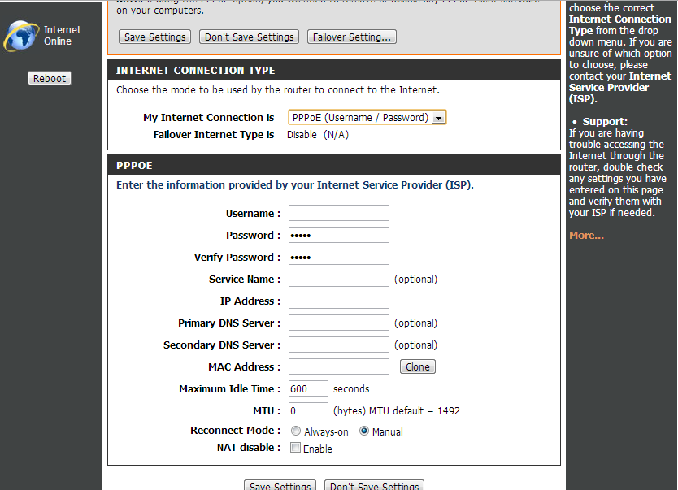

Username: Enter the username provided to you by your ISP.
Password: Enter the password provided to you by your ISP
Verify Password: Re-enter the password provided to you by your ISP.
Service Name: Enter the service name provided to you by your ISP (optional).
IP Address: Enter the IP address provided to you by your ISP (optional).
Primary DNS Server: If required, enter the primary DNS server address provided by your ISP.
Secondary DNS Server: If required, enter the secondary DNS server address provided by your ISP.
MAC Address: The default MAC Address is set to the Internet port’s physical interface MAC address on the Broadband Router. If you wish to specify a MAC address for this device, enter the address in this field, or use the Clone button to copy the MAC address of the network adapter currently being used.
Maximum Idle Time: The amount of time of inactivity before disconnecting an established PPPoE session. Setting the reconnect mode to “Always-on” will disable this feature.
Maximum Transmission Unit (MTU): If instructed to do so by your ISP, set the MTU (if not, the default setting for PPPoE is 1492).
Auto-reconnect: Select Always-on to have the PPPoE connection permanently connected. Select manual to require the connection to be re-established manually after a disconnection due to inactivity.

3G

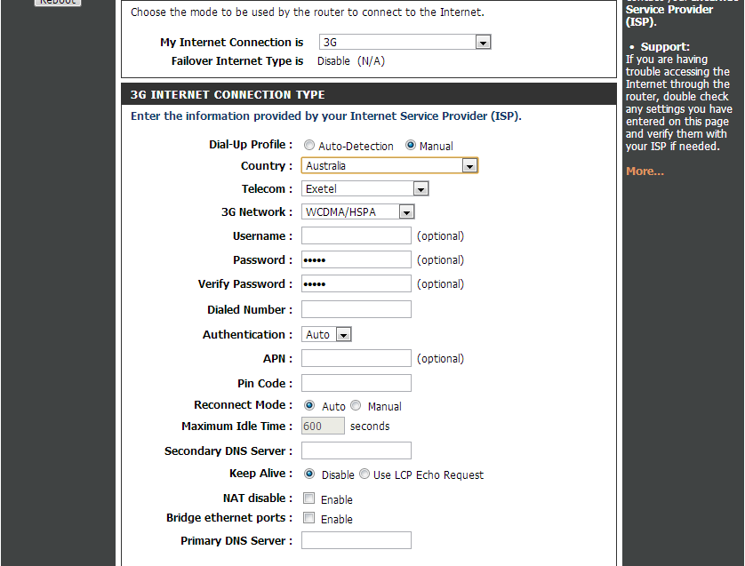

Account/Profile Name: Enter a name to identify the following 3G configuration.
Username: If required, enter the username for your 3G connection.
Password: If required, enter the username for your 3G connection.
Dialed Number: If required, enter a number to be dialed in order to establish a connection.
Authentication: Select PAP, CHAP, or Auto detection as specified by your ISP. The default authentication method is Auto.
APN: If required, enter the APN information specified by your ISP.
PIN: Enter the PIN associated with your SIM card.
Reconnect Mode: Select Auto to have the connection automatically established when the 3G modem is connected to the router. Select Manual to require the connection to be manually established.
Maximum Idle Time: Enter a period of time (in seconds) after which the connection will be disconnected due to inactivity.
Primary DNS Server: If required, enter the primary DNS server address provided by your ISP.
Secondary DNS Server: If required, enter the secondary DNS server address provided by your ISP.
Keep Alive: Depending on the requirements of your service provider, select Disable or Use LCP Echo Request.
Bridge Ethernet Ports: Enable this feature to convert the WAN port on the back of the DWR-113 into an additional LAN port.

Step 7: Click on the Setup tab at the top and click Wireless Settings from the menu on the left-hand side. Click Manual Wireless Connection Setup.

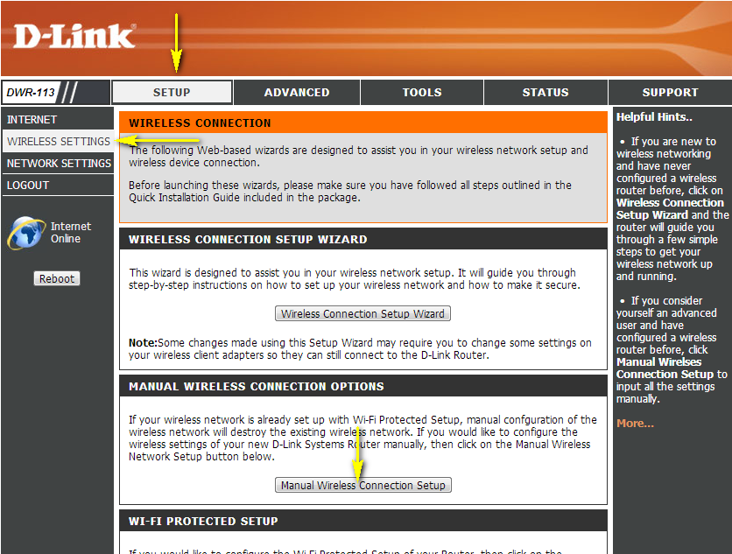

Step 8: Wireless Setting

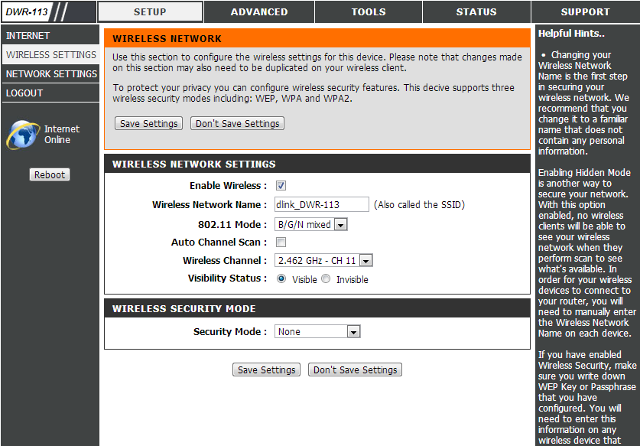

Enable Wireless: Select this checkbox to enable wireless access. When you set this option, the following parameters take effect.
Wireless Network Name: Also known as the SSID (Service Set Identifier), this is the name of your wireless network. Enter a name using up to 32 alphanumeric characters. The SSID is case-sensitive. The default name is“dlink_DWR-113”.
802.11 Mode:
- B/G mixed: Enable this mode if your network contains a mix of 802.11b and 802.11n devices. 802.11n devices will not be able to connect to your network in this mode.
- N mode: Enable this mode if your network has only 802.11n devices.
- B/G/N mixed: Enable this mode if your network contains a mix of 802.11b, 802.11g, and 802.11n devices.
Auto Channel Scan: A wireless network uses specific channels in the wireless spectrum to handle communication between clients. Some channels in your area may experience interference from other electronic devices. Choose the clearest channel to help optimize the performance and coverage of your wireless network.
Visibility Status: Select whether you wish to make your wireless network Visible or Invisible to devices scanning for available networks.
Security Mode: Select the desired security mode from the drop-down menu. It is recommended that you enable WPA-Personal security if supported by devices on your network. Select a WPA Mode and Cipher Type from the drop-down menus, and enter a Network Key (password) in the field provided. The network key can contain a combination of letters, numbers and symbols 8-63 characters in length.

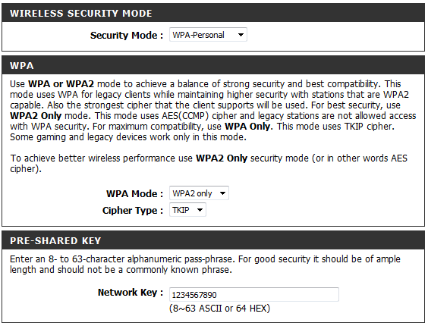

How do I change the Administrator password on my router?

Step 1: Open an Internet browser (such as Internet Explorer) and enter http://192.168.0.1 into the address bar. Press Enter.

Step 2: The default username is Admin. Enter the password for your Admin account. If you have not changed the password from its default, the password field should be left blank. Click Login.

Step 3: Click Tools tab at the top of the page and then click Admin from the menu on the left-hand side.

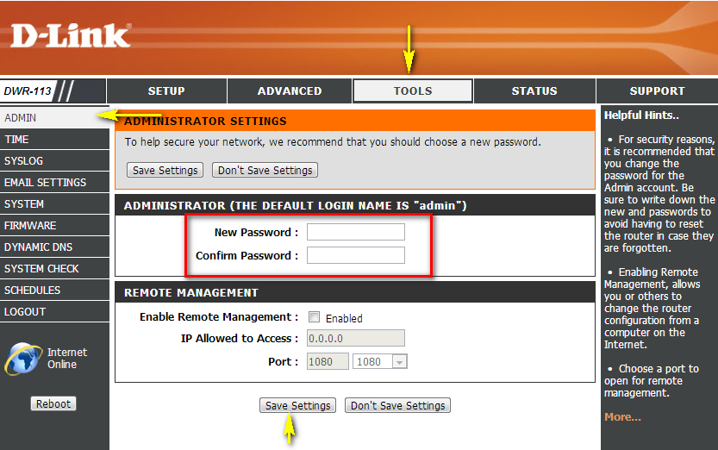
Step 4: To change the Administrator password, enter a new password in the Password field. Verify the password again in the Confirm Password field.

Step 5: Click Save Settings to save the current configuration.

I have forgotten my wireless password, how do I recover it?

Step 1: Open an Internet browser (such as Internet Explorer) and enter http://192.168.0.1 into the address bar. Press Enter.

Step 2: The default username is Admin. Enter the password for your Admin account. If you have not changed the password from its default, the password field should be left blank. Click Login.

Step 3: Click on the Setup tab at the top of the page and click Wireless Settings from the menu on the left-hand side.

Step 4: Click on Manual Wireless Connection Setup.

Step 5: Scroll down the page to "Wireless Security Mode". In this section, your current wireless password will be displayed in the Network Key field. If you wish to change the password, enter a new password in this field. Click Save Settings at the bottom of the page if you have made changes to the password settings.

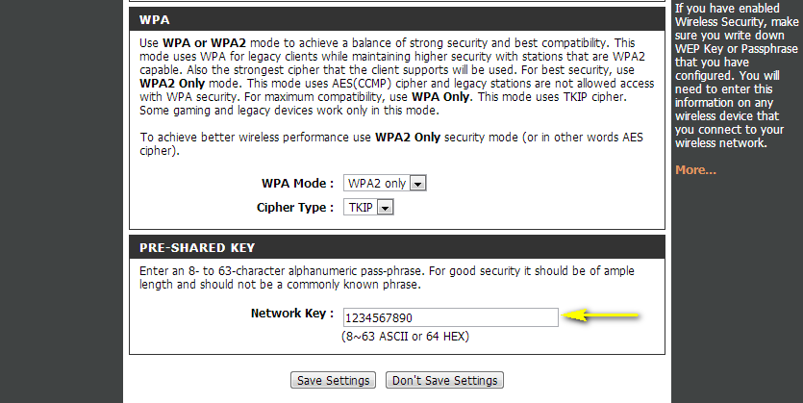

How do I change the IP Address of my router?

Example: You wish to change the IP address of the router to avoid IP address conflicts with other devices on your network.

Step 1: Open an Internet browser (such as Internet Explorer) and enter http://192.168.0.1 into the address bar. Press Enter.

Step 2: The default username is Admin. Enter the password for your Admin account. If you have not changed the password from its default, the password field should be left blank. Click Login.

Step 3: Click on the Setup tab at the top of the page and click Network Settings from the menu on the left-hand side.

Step 4: Under Router Settings, enter the desired IP address for your router. The IP Address configured here is the IP address used to access the web-based management interface. If you change the IP address here, you may need to adjust your PC´s network settings in order to access the network again, and you will need to enter the new IP address in order to access the router’s web-based configuration interface.

Step 5: Click on Save Settings.
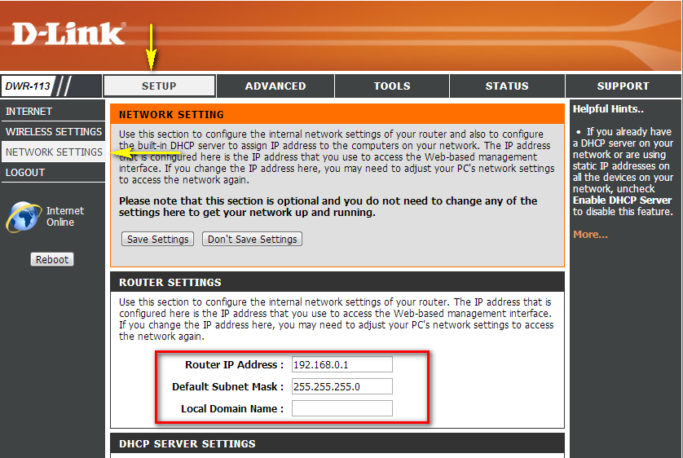

How do I change the 802.11 mode on my router?

Example: If your device only supports 802.11b or 802.11g and it can’t connect to the router then you can try to change the 802.11 mode to solve the problem. If your devices all use the same 802.11 standard, you can set an ‘only’ mode to improve performance.

Step 1: Open an Internet browser (such as Internet Explorer) and enter http://192.168.0.1 into the address bar. Press Enter.

Step 2: The default username is Admin. Enter the password for your Admin account. If you have not changed the password from its default, the password field should be left blank. Click Login.
Step 3: Click the Setup Tab at the top of the page and click Wireless Settings from the menu on the left-hand side.

Step 4: Click Manual Wireless Connection Setup.
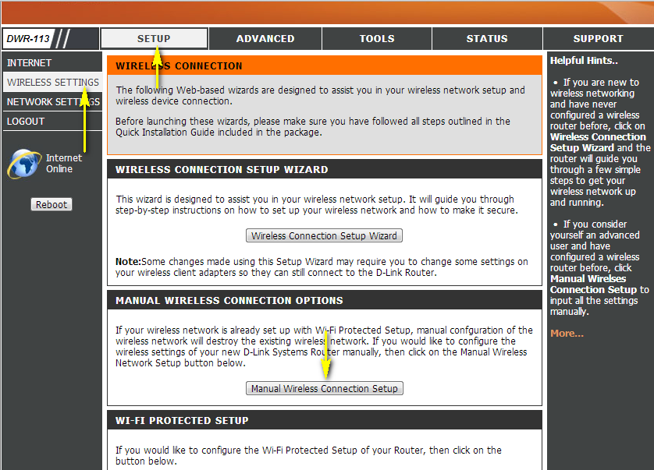

Step 5: Under the Wireless Network Settings, Choose your desired 802.11 Mode from the drop-down menu.

- B/G mixed - Wireless devices compatible with 802.11b or 802.11g can connect.
- N mode - Only wireless devices compatible with 802.11n can connect.
- B/G/N mixed (default) - Wireless devices compatible with 802.11n, 802.11g, and 802.11b can connect.

Click Save Settings to save the current configuration.
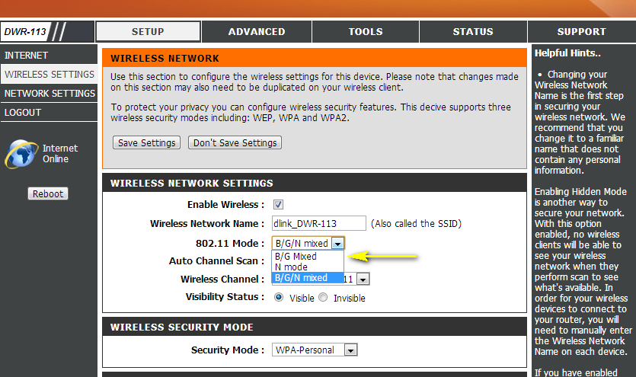

How do I change the channel on my router?

Example: Your router’s wireless performance may be affected by interference from other nearby routers. You can change the wireless channel to one which has less interference.

Step 1: Open an Internet browser (such as Internet Explorer) and enter http://192.168.0.1 into the address bar. Press Enter.

The default username is Admin. Enter the password for your Admin account. If you have not changed the password from its default, the password field should be left blank. Click Login.

Step 2: Click the Setup Tab at the top of the page and click Wireless Settings from the menu on the left-hand side.

Step 3: Click Manual Wireless Connection Setup.

Step 4: Uncheck the Enable Auto Channel Scan box.
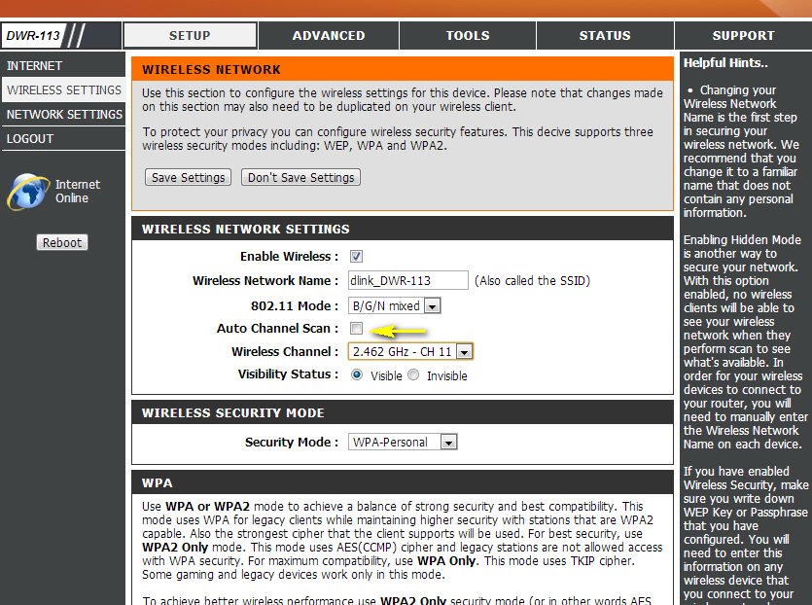

Step 5: Select a channel from the drop-down menu. For best results, use channel 1, 6, or 11.
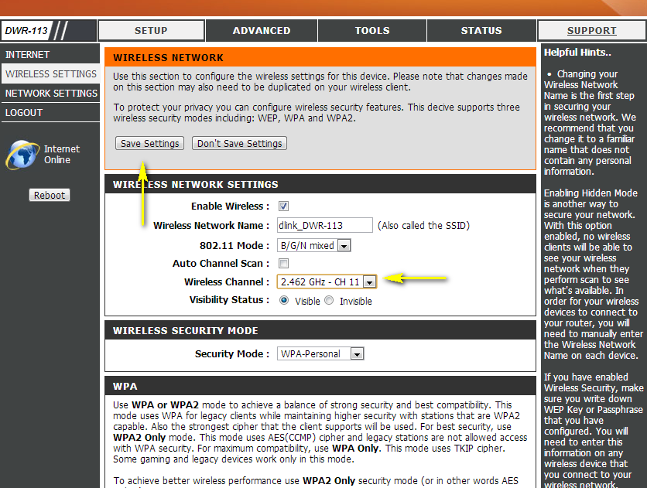

Step 6: Click Save Settings to save your configuration.

Note: In most cases, you only need to change the channel on the router. Most wireless adapters will automatically detect the channel used by your wireless network.

How do I change the SSID/network name of my router?

Step 1: Open an Internet browser (such as Internet Explorer) and enter http://192.168.0.1 into the address bar. Press Enter.

Step 2: The default username is Admin. Enter the password for your Admin account. If you have not changed the password from its default, the password field should be left blank. Click Login.

Step 3: Click the Setup tab at the top of the page and click Wireless Settings from the menu on the left-hand side

Step 4: Click Manual Wireless Connection Setup.

Step 5: Next to Wireless Network Name, type in a new SSID. 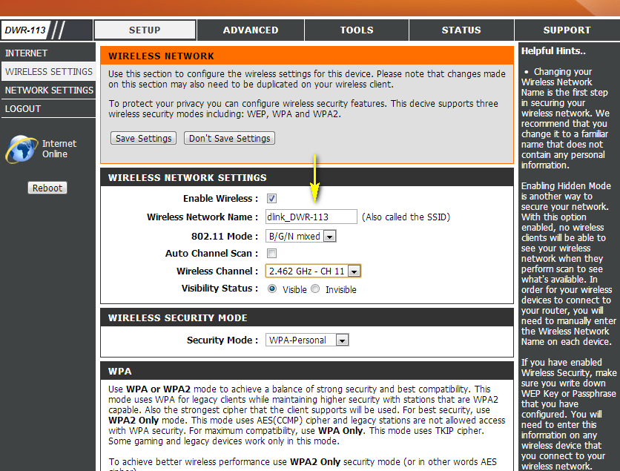

Step 6: Click Save Settings to save your configuration.

How do I enable WEP encryption so my older devices can connect?

Step 1: Open an Internet browser (such as Internet Explorer) and enter http://192.168.0.1 into the address bar. Press Enter.

Step 2: The default username is Admin. Enter the password for your Admin account. If you have not changed the password from its default, the password field should be left blank. Click Login.

Step 2: Click the Setup tab at the top of the page and click Wireless Settings from the menu on the left-hand side.

Step 3: Click Manual Wireless Connection Setup.

Step 4: Under the Wireless Security Mode section, select WEP from the Security Mode drop-down menu. In the section below, select the desired Authentication, and the WEP Encryption type from the drop-down menus.

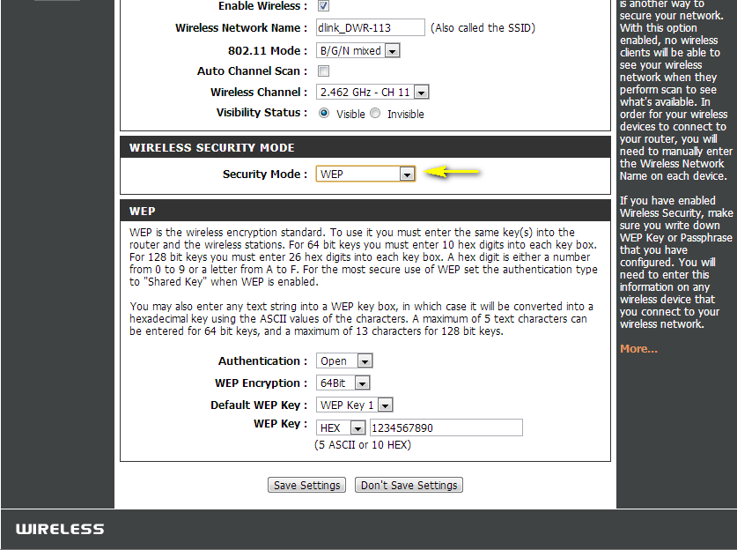

Step 5: Select whether to use a HEX or ASCII WEP key, and enter the desired WEP Key in the field provided. For 64 bit keys you must enter 10 hex digits into the WEP key box. For 128 bit keys you must enter 26 hex digits into the WEP key box. A hex digit is either a number from 0 to 9 or a letter from A to F.

If you select to use an ASCII key, the characters entered will be converted into a hexadecimal key using the ASCII values of the characters. A maximum of 5 text characters can be entered for 64 bit keys, and a maximum of 13 characters for 128 bit keys.
Click Save Settings to save your configuration.

How do I change the Wi-Fi Password on my router?

Step 1: Open an Internet browser (such as Internet Explorer) and enter http://192.168.0.1 into the address bar. Press Enter.

The default username is Admin. Enter the password for your Admin account. If you have not changed the password from its default, the password field should be left blank. Click Login.

Step 2: Click the Setup tab at the top of the page and click Wireless Settings from the menu on the left-hand side.

Step 3: Click Manual Wireless Connection Setup.
Step 4: Scroll down the page to the Wireless Security Mode section. In this section, you can specify the wireless password in the Network Key field. You can specify a new password.

Step 5: Click Save Settings at the top of the page once complete.

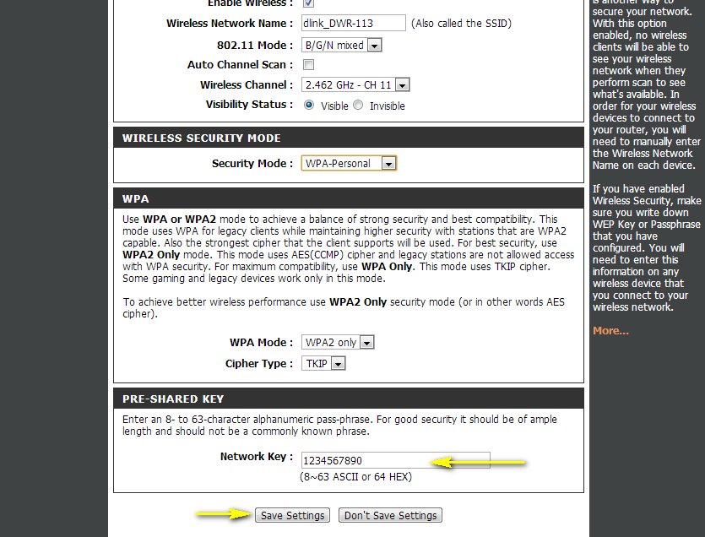

How do I reset my router to factory default settings?

Example: If you forget the password for you router’s configuration interface, you can do a factory reset to return the settings to the factory defaults.
Note: Performing a factory reset will erase all current settings, and this action cannot be undone.

Step 1: With the unit on, use the end of a paperclip to press the reset button, which is located inside a small hole on the front of the unit.
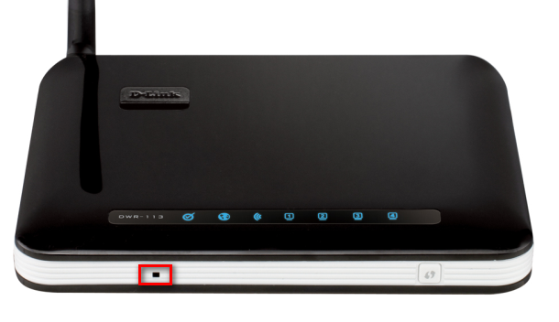
Step 2: Using the paperclip, press and hold the reset button for more than ten seconds. The power light on the front of the router will turn orange to indicate that the unit is restarting.
Step 3: The unit will reboot automatically. Once the power light stops blinking, the unit has been reset and is ready to use. Resetting the router does not reset the firmware to an earlier version, but it will change all settings back to factory defaults.
Note: The factory default username is Admin, and the password field should be left blank.

How do I set up Website Filtering on my router?

Step 1: Open an Internet browser (such as Internet Explorer) and enter http://192.168.0.1 into the address bar. Press Enter.

Step 2: The default username is Admin. Enter the password for your Admin account. If you have not changed the password from its default, the password field should be left blank. Click Login.
Step 3: Click the Advanced tab at the top of the page then URL Filter from the menu on the left-hand side of the screen. 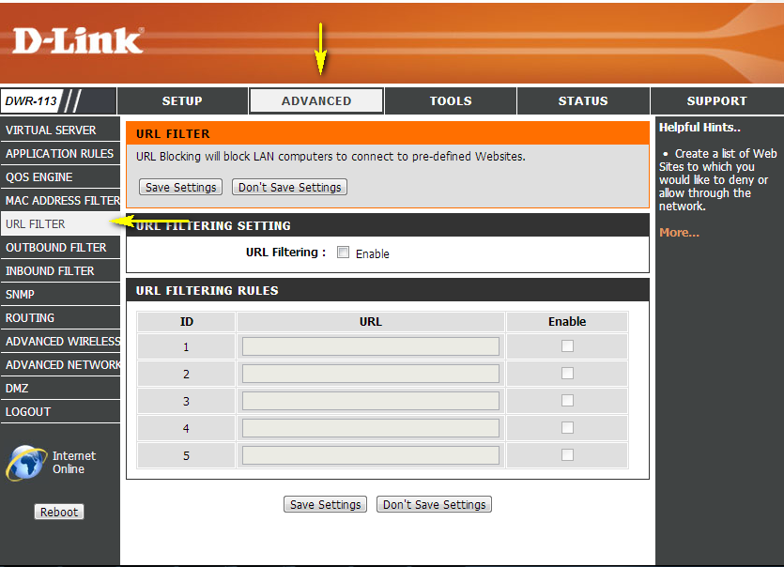
Step 4: Check the URL Filtering check box. Type the website URLs to be blocked on this router in the URL column and check the Enable check box in the right-hand column. Click Save Settings when finished to save the configuration.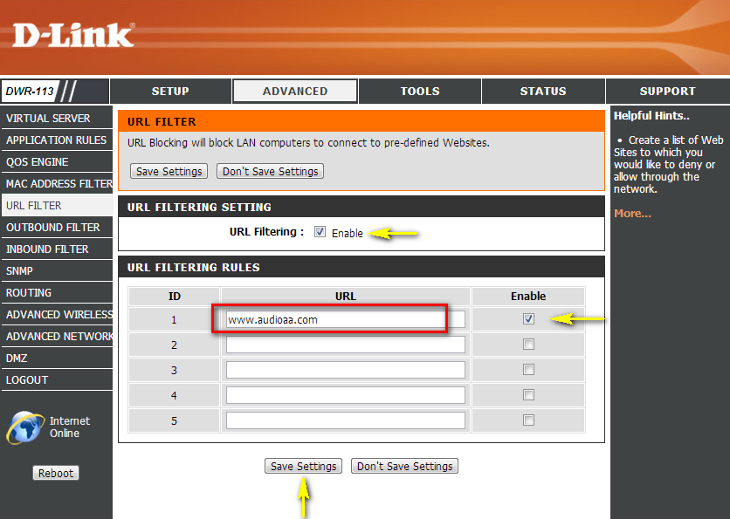

How do I upgrade the firmware on my router?

Warning: A firmware upgrade should only be conducted over a wired connection between your computer and the DWR-113. Do not turn off the router while the upgrade process is being carried out, as this may damage the unit.

Step 1: Download the latest firmware for your DIR Series router from http://www.dlink.com/support or your local D-Link support website.

Step 2: Open an Internet browser (such as Internet Explorer) and enter http://192.168.0.1 into the address bar. Press Enter.

Step 3: The default username is Admin. Enter the password for your Admin account. If you have not changed the password from its default, the password field should be left blank. Click Login.

Step 4: Click on the Tools tab at the top of the page and then click Firmware from the menu on the left-hand side. Under Firmware Upgrade click on the Browse… button and locate the .bin file you downloaded in Step 1. Highlight the file by clicking on it once and then click Open.

Step 5: Click on Upgrade to upgrade firmware. It may take up to 30 seconds for the upgrade to complete. When the upgrade is complete, a confirmation window will appear, click Continue when it appears. The firmware is now upgraded.
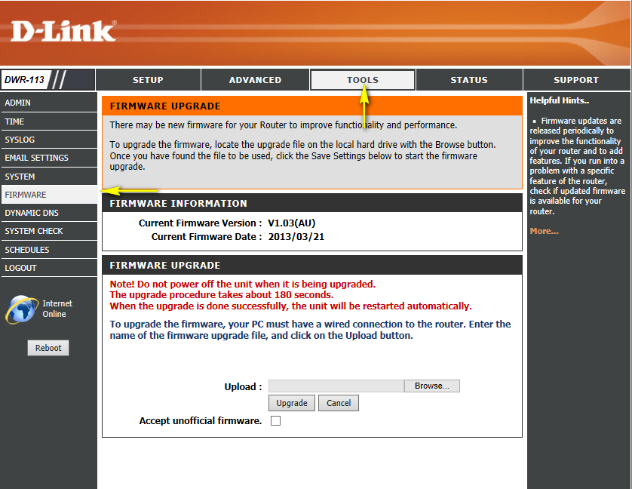

How do I back up the router’s configuration to my computer?

Step 1: Open an Internet browser (such as Internet Explorer) and enter http://192.168.0.1 into the address bar. Press Enter.

Step 2: The default username is Admin. Enter the password for your Admin account. If you have not changed the password from its default, the password field should be left blank. Click Login.
Step 3: Click the Tools tab at the top of the page and then click System from the menu on the left-hand side.
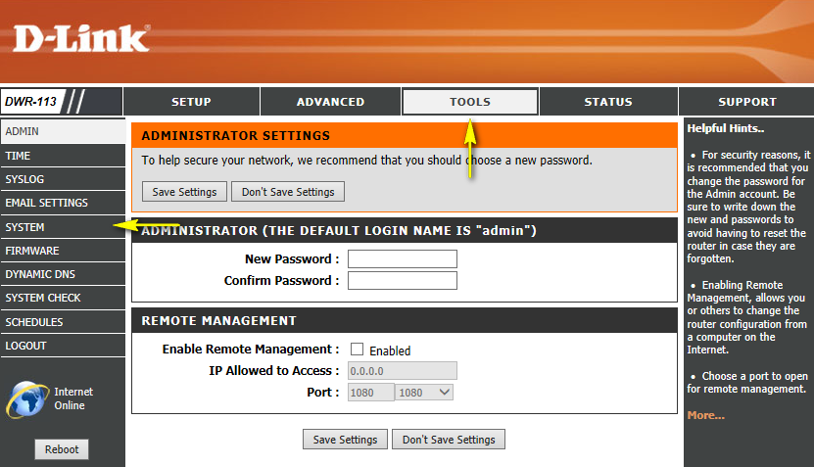

Step 4: To save the current configuration settings of your wireless router to a file, click Save next to “Save Settings To Local Hard Drive”. Depending on your browser, the file may be automatically saved to your ‘Downloads’ folder, or a ‘Save File’ or similar dialog box will appear, asking you where you wish to save the file.
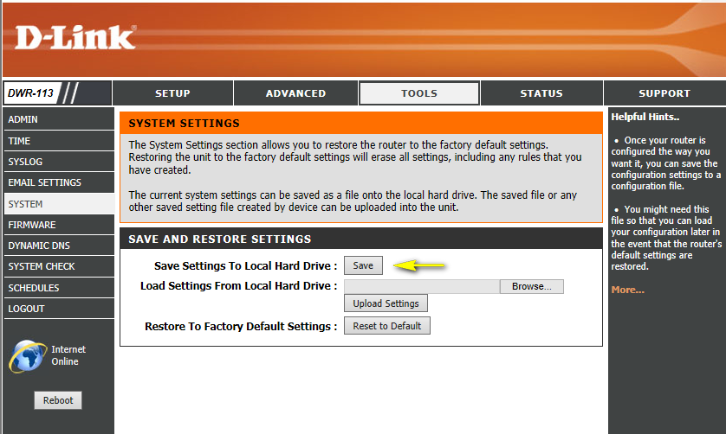

To load a previously saved configuration file, click Browse… next to “Load Settings From Local Hard Drive”. Once you have located the file (config.bin) on your hard drive, click OK and then click Upload Settings.

Note: If you have upgraded or downgraded the firmware on your wireless router, do not load configuration files that were saved using a previous firmware version. The load will not be successful, and can damage the unit.

How do I configure QoS (Quality of Service) settings on my router?

Step 1: Open an Internet browser (such as Internet Explorer) and enter http://192.168.0.1 into the address bar. Press Enter.
Step 2: The default username is Admin. Enter the password for your Admin account. If you have not changed the password from its default, the password field should be left blank. Click Login.

Step 3: Click on the Advanced tab at top of the page and then click QOS Engine from the menu on the left-hand side.
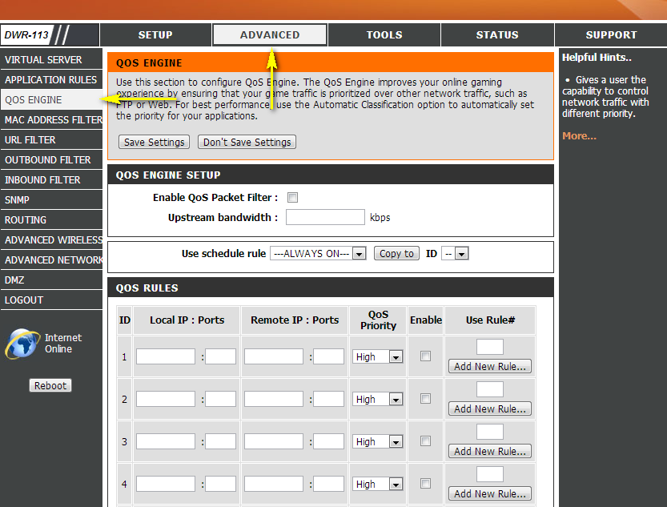

Step 4: Ensure the Enable QoS Packet Filter box is checked. Enter your upstream bandwidth (in Kbps) in the field provided. This will depend on your Internet service plan with your ISP. Bandwidth is usually stated in a pair indicating downlink and uplink speeds, respectively (ie: 10M/2M indicates a downlink speed of 10 Mbps and an uplink speed of 2 Mbps, 1 Mbps = 1,024 Kbps).

Step 5: Select a schedule for the QoS packet filter using the Use schedule rule drop-down menu. Select ALWAYS ON to have the packet filter permanently enabled. To specify a custom schedule, use the Schedules option from the Tools menu at the top of the page.

Step 6: Example: Set a device (IP address 192.168.1.100) on the local LAN to access web services (port 80) with highest priority.
Enter the IP address of the device you wish to apply the QoS engine to in the Local IP column, and enter the port of the applicable service under the Ports column. Select a priority level from the drop-down menu under the QoS Priority column, and check the box under the Enable column to enable the rule. You can apply specific schedules to each rule by entering the corresponding number of any pre-defined schedule you wish to use, or you can create a new schedule by clicking the Add New Rule… button. Enter “0” as the rule number for “ALWAYS ON”.

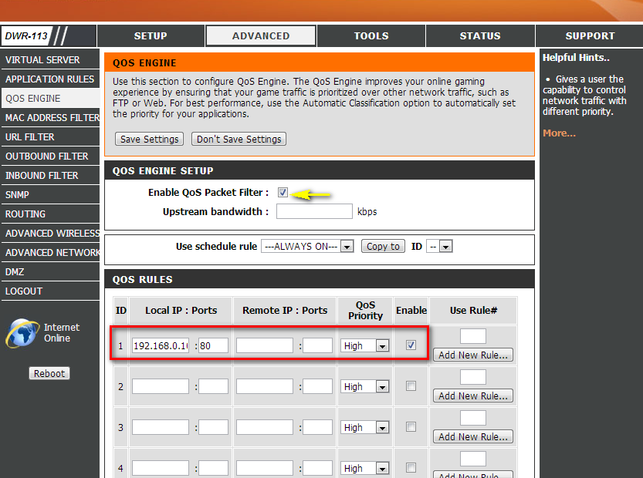

Step 6: Click Save Settings when finished.

How many simultaneous users can my Wi-Fi network handle?
The more devices that are simultaneously connected to your device, the slower the transfer speed will be for each device. D-Link recommends 15 simultaneously connected users as the maximum number.

How do I connect my Wi-Fi enabled computer to my wireless router?

Note: The following instructions and screenshots are for Windows® 7. Other versions of Windows may have slightly different appearances.
Step 1: Click on the network icon in the bottom right corner (next to the clock).
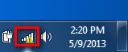

Step 2: Select the wireless network you want to connect to and click Connect.
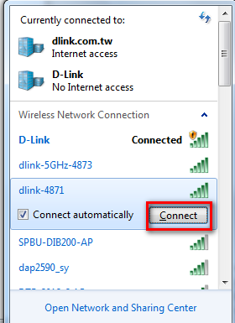

Step 3: If you have a Wi-Fi password configured on your router, enter the password and click OK.

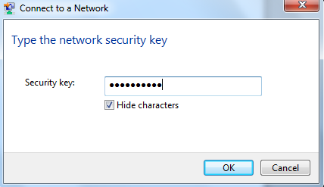
Step 4: Select the Network Type.
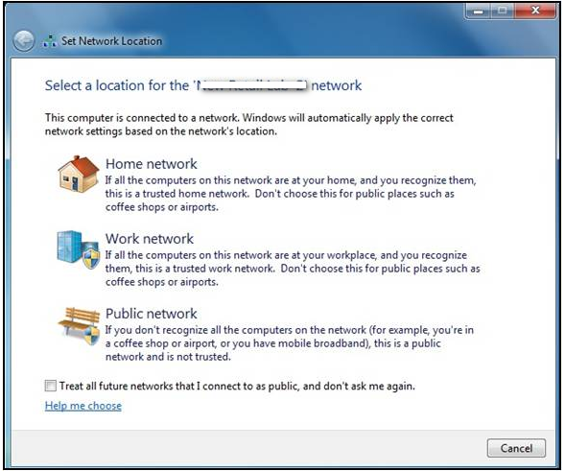

Step 5: Your computer is now connected. The computer should now automatically connect to this network when it is within range.
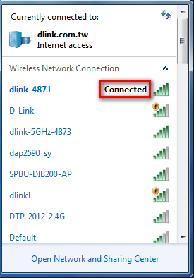

How do I connect my iPad® to my wireless router?

Step 1: Tap the Settings icon on your iPad.
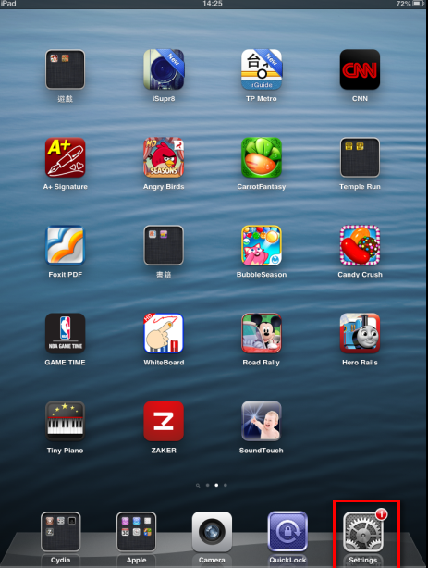

Step 2: Open the Wi-Fi menu. If Wi-Fi is off, turn it on.
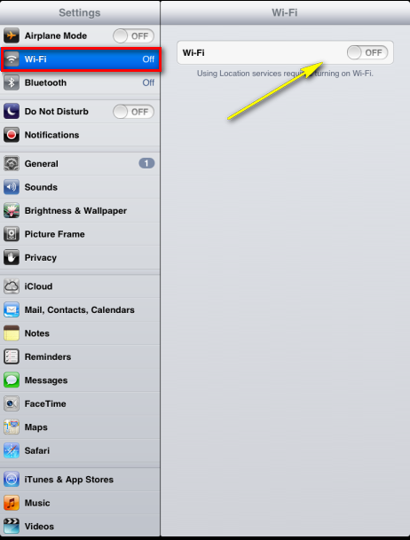

Step 3: Select the wireless network you want to connect to by tapping the network name.

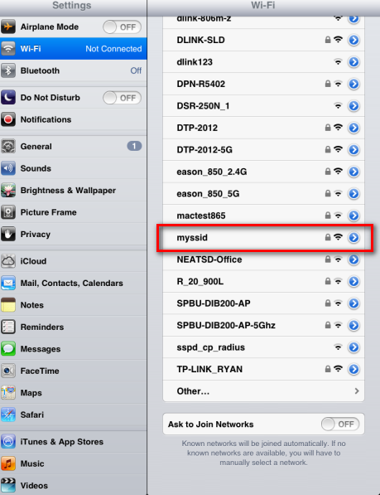

Step 3: If you have a Wi-Fi password configured on your router, enter the password and tap Join.
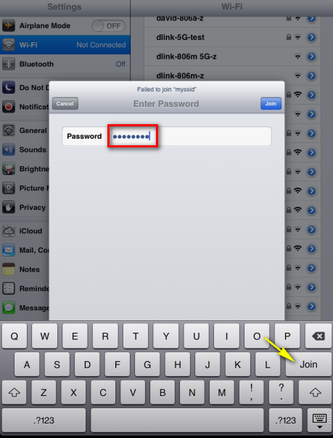

Step 5: You are now connected to the wireless network.
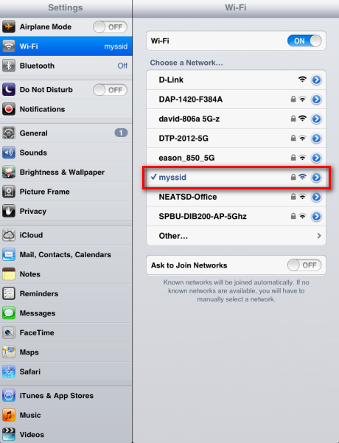

Step 6: Ensure that the iPad has received an IP address from the router. Tap the blue arrow next to the network name to bring up the network settings. An IP address will be displayed to indicate a successful connection.
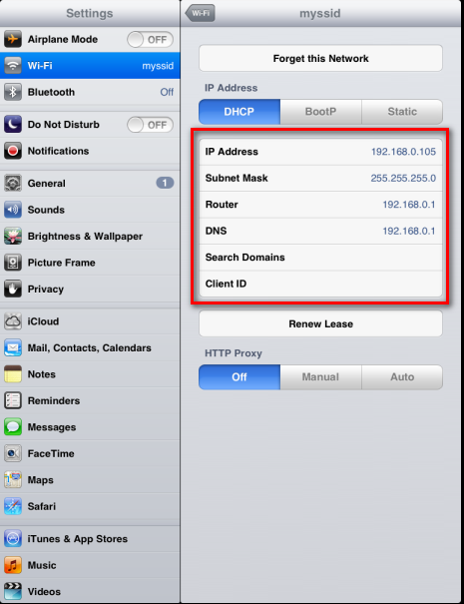

How do I connect my iPhone® to my wireless router?

Step 1: Tap the Settings icon on the home screen of your iPhone.
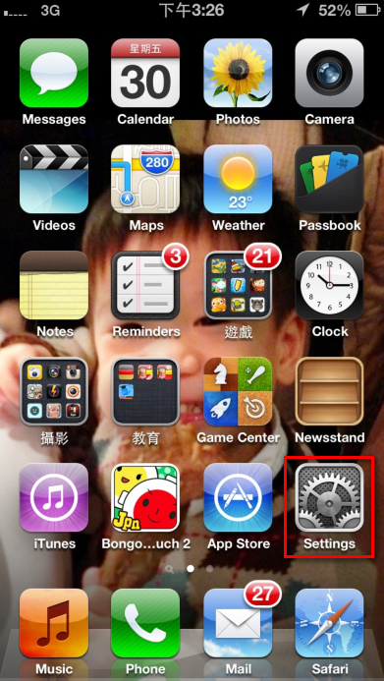

Step 2: Tap to open the Wi-Fi settings.
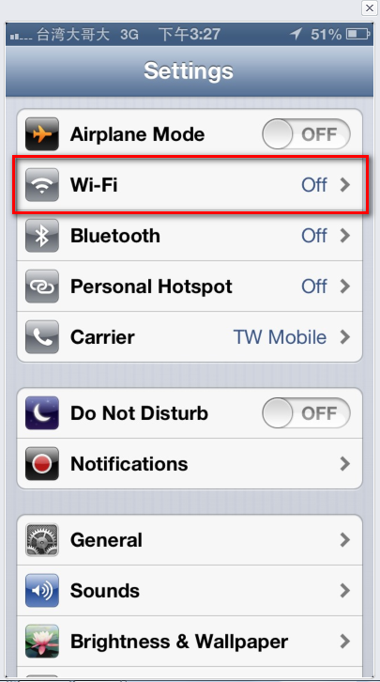

Step 3: Select the wireless network you want to connect by tapping the network name from the list.

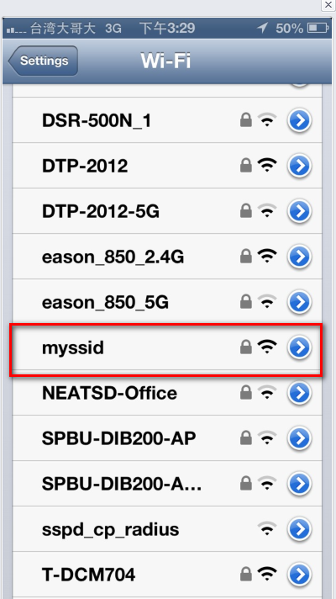

Step 4: If you have a Wi-Fi password configured on your router, enter the password and tap Join.
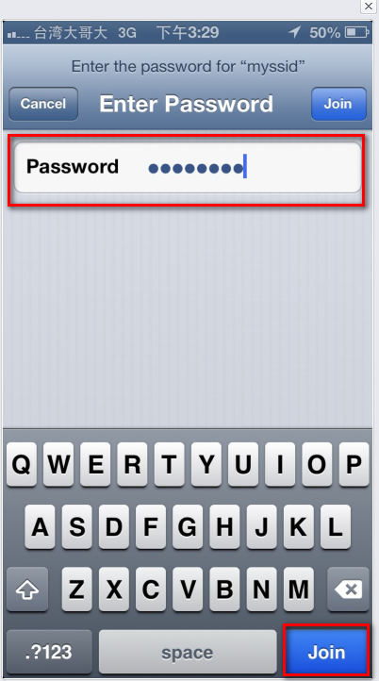

Step 5: The iPhone is now connected to your wireless network.
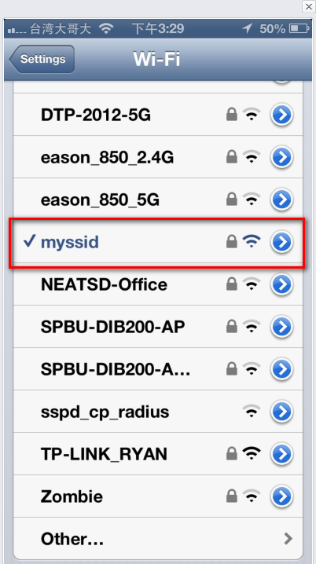

Step 6: Tap the arrow button to go to the connection settings page and confirm that the iPhone has received an IP address.

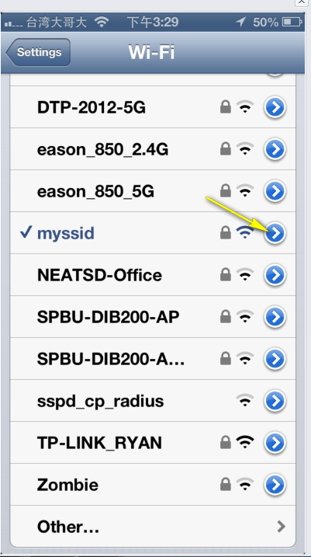
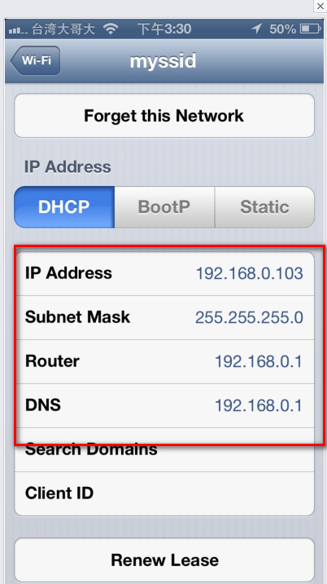

Disclaimer: iPad and iPhone are trademarks of Apple Inc., registered in the U.S. and other countries. Windows and Internet Explorer are registered trademarks of Microsoft Corporation in the United States and/or other countries.

