Contents
1. How do I set up and install my router? 1
2. How do I change the administrator password on my router? 13
3. How do I change the IP address on my router? 16
4. How do I configure mydlink SharePort on my DIR series portable router? 18
5. How do I configure mydlink SharePort Web Access on my router? 27
6. How do I change the SSID/network name of my router? 30
7. How do I change the Wi-Fi password on my router? 32
8. How do I upgrade the firmware on my router? 34
9. How do I charge other devices using my DIR-508L? 36
10. How do I back up the router’s configuration to my computer? 36
11. How many simultaneous users can my Wi-Fi network handle? 38
12. How do I connect my laptop to my wireless router? 38

How do I set up and install my router?
Step 1: Peel the protective film from the top and bottom of the device.
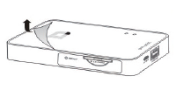

Step 2: Charge the device by connecting the power adapter to the DIR-508L and plugging it in to a wall outlet. Charge the device for at least 4 hours or until the battery LED indicator turns solid green.
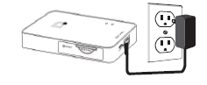

Step 3: Connect to your network equipment:
- Wired Internet Connection - Connect your DSL /cable modem or wired Internet line to the DIR-508L using an Ethernet cable.

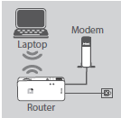

- 3G/4G/LTE Connection - You will need a compatible 3G/4G USB adapter with an active SIM card and mobile data plan. Please check your local D-Link website for more information. Plug the 3G/4G USB adapter into the USB port on the DIR-508L.

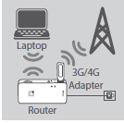

- Wi-Fi Hotspot Connection - You will need the name and password of the Wi-Fi hotspot that you want to connect to.

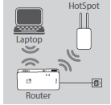

Step 4: Turn on the DIR-508L by sliding the ON /OFF/Charge switch to ON.

Step 5: On your PC or mobile device, connect to the DIR-508L’s wireless network.
By default, the settings are:
--Wi-Fi Network Name (SSID): DIR508L
-- Password: (leave this blank)

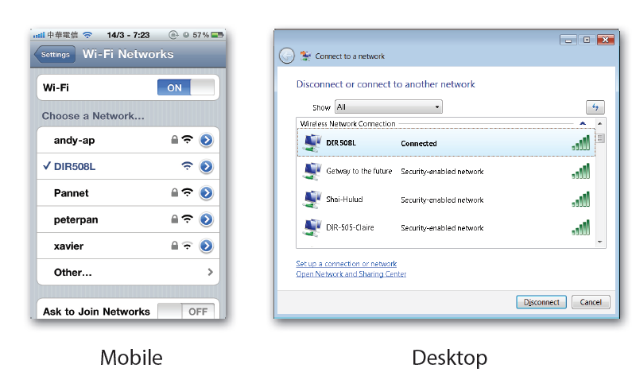
Step 6: Once connected, open your web browser and enter http://dlinkrouter or http://dlinkrouter.local into the address bar.

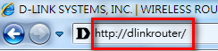

Step 7: At the login page, enter the Admin password. If you have not changed the administrator password, leave the field blank. Click Log In.

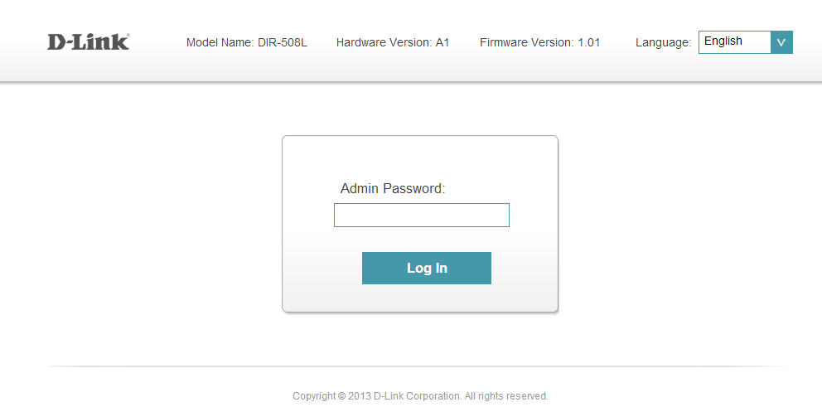
After logging in, you will see the Current Status page. If the Internet icon is blue and there is a green check mark between it and the DIR-508L icon, there is an active Internet connection present, and the device is ready for use.

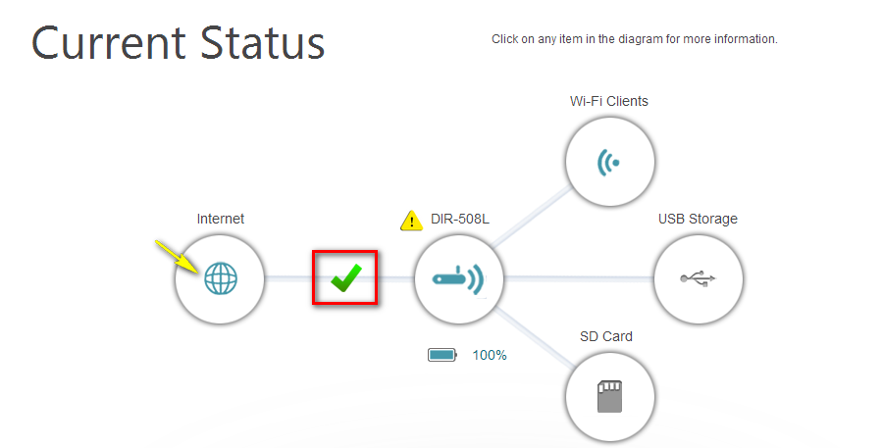

Step 8: If the Internet icon is grey and there is an exclamation mark icon next to it, click on the Internet icon to view the router’s Internet settings.
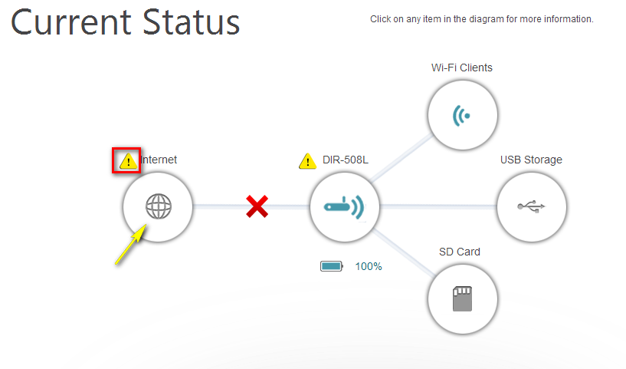

Method 1 - Connecting to a Wi-Fi Hotspot:
- Click Next to search for available Wi-Fi hotspot networks.
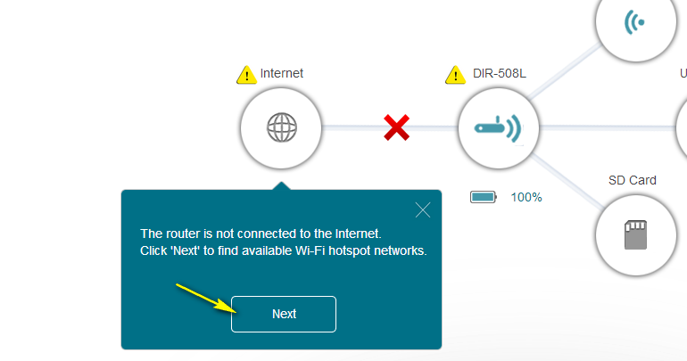

- Click on the name of the network which you want to connect to, then click Select.
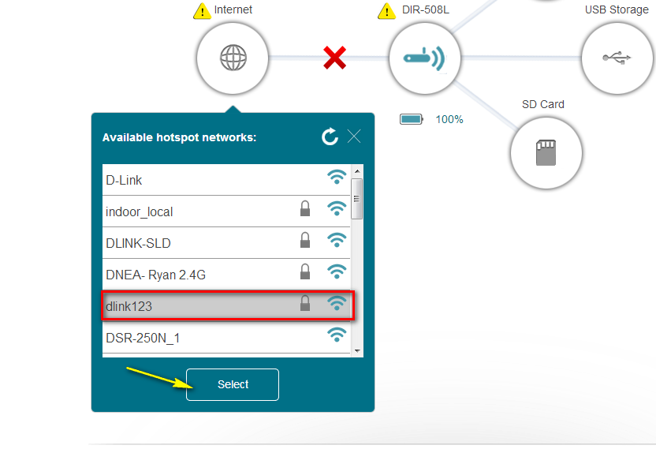
- If a password is required, enter the password and click Save.

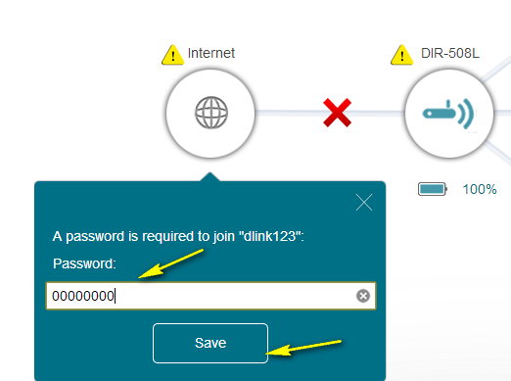

A confirmation message will appear. Click Continue. The router will save the current configuration and restart. Any Internet connection will be temporarily disconnected during this time.
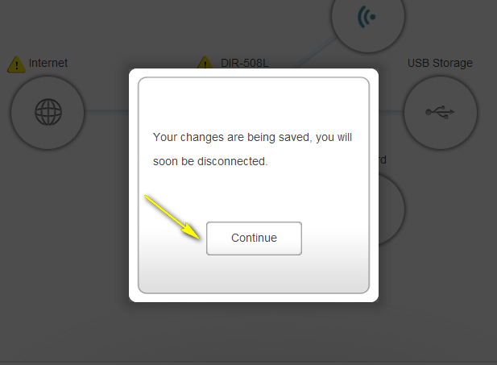

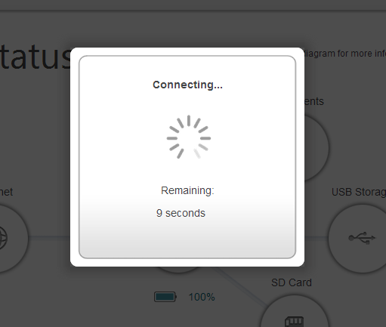
If the connection is successful, there should be a green check mark between the Internet and DIR-508L icons.
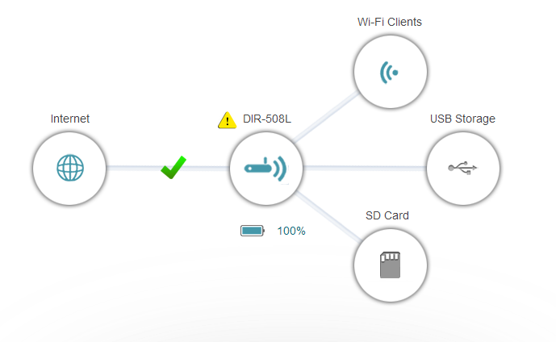
Method 2 - Using a Wired Ethernet Connection (PPPoE):
Plug the Ethernet cable from your DSL modem into the Ethernet port on the DIR-508L.
Enter the Username and Password given to you by your Internet Service Provider and click Save.

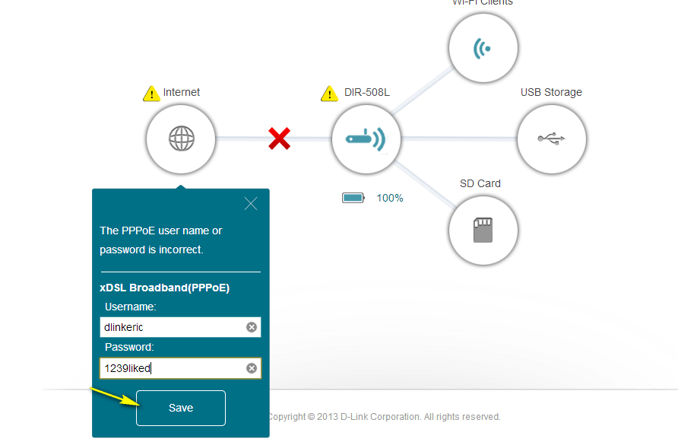

If the connection is successful, there should be a green check mark between the Internet and DIR-508L icons.

Method 3 - Using a 3G/4G USB Adapter:
Plug your 3G/4G USB modem into the USB port on the DIR-508L.
If your SIM requires a PIN, enter it and click Save.
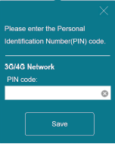
If necessary, the wizard may ask you to enter the APN, Dial-up Number, Username, and Password details given to you by your service provider.
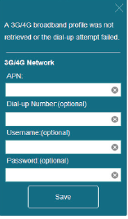
If the connection is successful, there should be a green check mark between the Internet and DIR-508L icons.

mydlink Cloud Services registration:
With mydlink Cloud Services, you can use the mydlink SharePort app to remotely or locally access content on a USB drive connected to your router.
To get started with mydlink Cloud Services, you are required to have a mydlink account and need to link this router to you mydlink account.

Move the cursor to the Settings tab then click mydlink
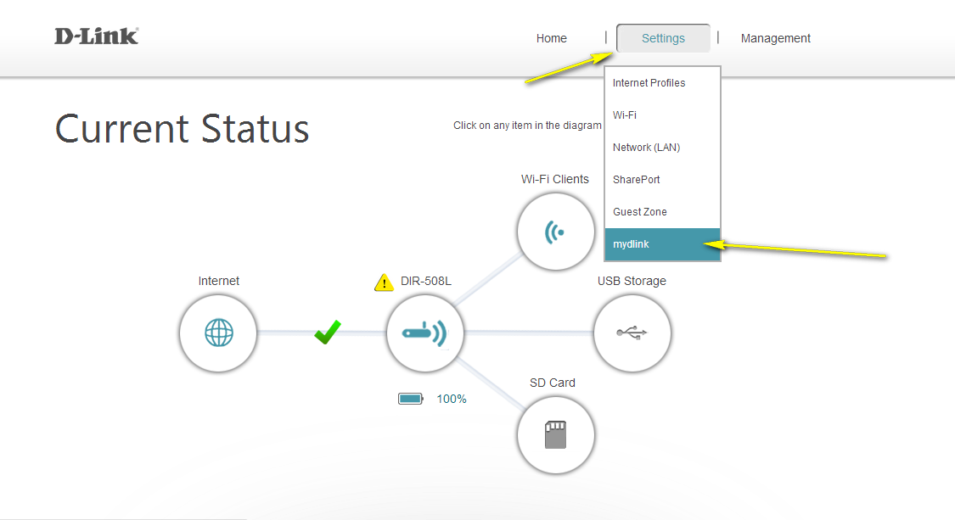
Select “Yes, I have a mydlink account” if you have previously registered a mydlink account; Select “No, I want to register and login with a new mydlink account” if you would like to create a new mydlink account.

a) If you selected “Yes, I have a mydlink account”, please enter your existing mydlink account name and password. Then click Save.
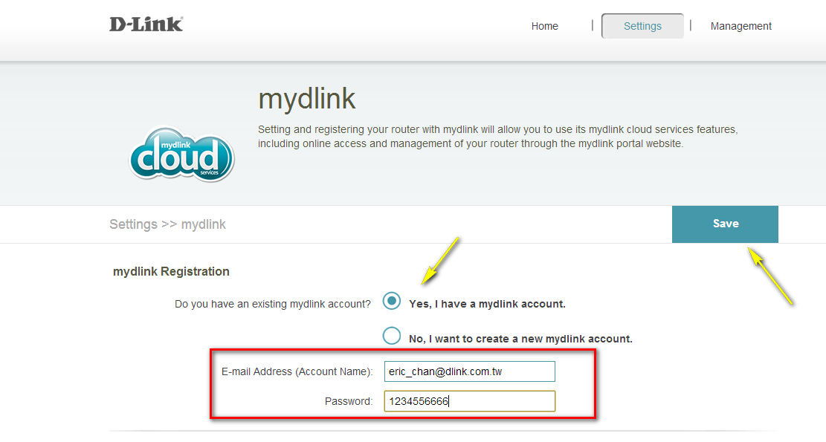

b) If you selected “No, I want to create a new mydlink account”, please fulfill the required information in order to create a new mydlink account.
Note: Your mydlink password is the password used to log in to the mydlink web portal and mydlink mobile apps. This is NOT the same as your router’s password.
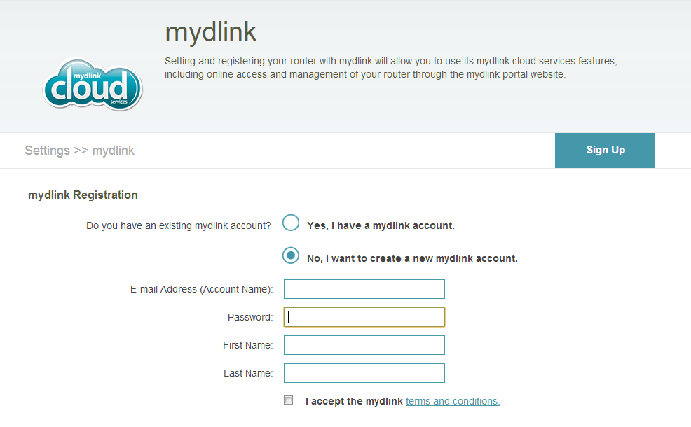

How do I change the administrator password on my router?

Step 1: Open your web browser and enter http://dlinkrouter or http://dlinkrouter.local into the address bar

Step 2: At the login page, enter the Admin password. If you have not changed the administrator password, leave the field blank. Click Log In.

Step 3: Move the cursor to the Management tab and then click Admin.
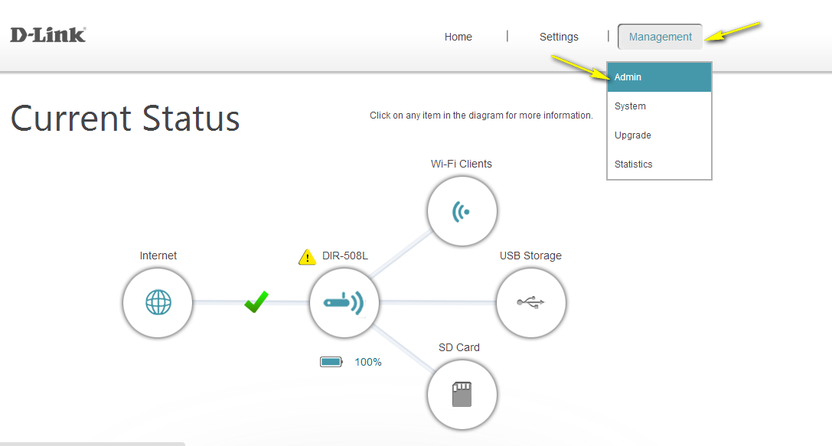

Step 4: To change the administrator password, enter a new password in the Admin Password section.
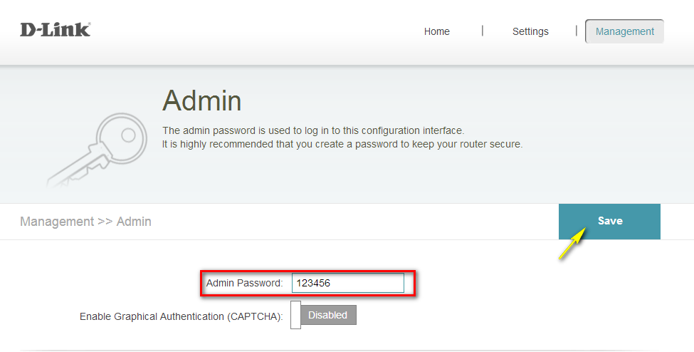
Step 5: Click Save to save the settings.

3. How do I reset my DIR-508L to factory default settings?

Example:
- If you forget your router’s password, you can perform a reset to return all settings to the factory default.

Step 1: While the router is on, use the end of a paper clip to press the button inside the pinhole on the side of the router, as highlighted by the red square below.
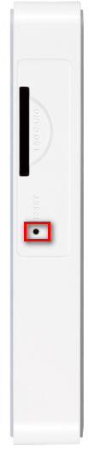
Step 2: Hold the button down for 10 seconds and then release.
Step 3: The unit will reboot automatically. Once the WLAN light stops blinking, the unit has been reset. Resetting the router does not reset the firmware to an earlier version, it only changes all settings back to factory defaults.
Note: 1. The factory default username is Admin, and there is no password.
2. You will need to register the router with mydlink again after a factory reset.

How do I change the IP address on my router?

Example: You are using other networking equipment and want to change the router’s IP address in order to avoid any IP conflicts.

Step 1: Open your web browser and enter http://dlinkrouter or http://dlinkrouter.local into the address bar.

Step 2: At the login page, enter the Admin Password. If you have not changed the administrator password, leave the field blank. Click Log In.

Step 3: Move the cursor to the Management tab and then click Network (LAN).
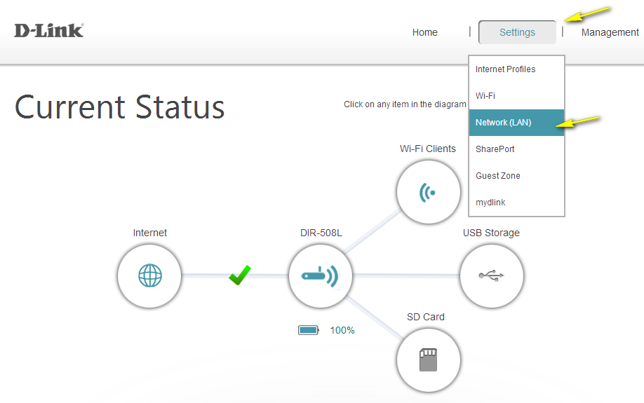

Step 4: Under Network Settings, type in the router´s new Device IP Address and Subnet Mask. The IP address configured here is also the IP address you use to access the web-based management interface. If you have multiple D-Link routers, you can also change the name of the device, which is also the address which can be typed into the web browser address bar to access the configuration interface (default is http://dlinkrouter.local). If you change this device name, you should use the new device name in place of “dlinkrouter” when you type the device adderss in to your web browser’s address bar. 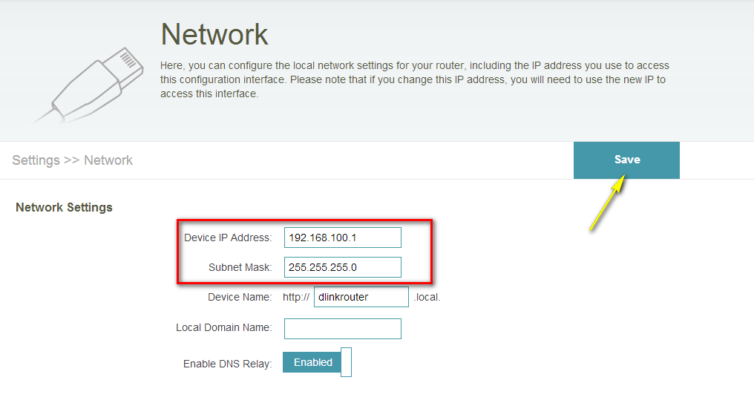
Step 5: Click Save.

How do I configure mydlink SharePort on my DIR series portable router?

Step 1: Ensure your USB drive is properly connected to your DIR-508L

Step 2: Check the USB drive/SD card status using the router’s web interface.
Step 2.1: Step 1: Open your web browser and enter http://dlinkrouter or http://dlinkrouter.local into the address bar.

Step 2.2: At the login page, enter the Admin Password. If you have not changed the administrator password, leave the field blank. Click Log In.

Step 2.3: Click the USB Storage icon to bring up the storage status information. Confirm that this information reflects the characteristics of the USB storage device that you have inserted into the DIR-508L’s USB port.
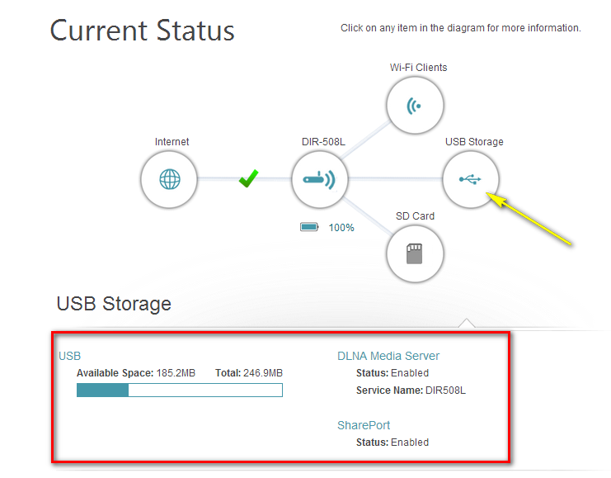

Step 3: Move the cursor to the Settings tab and then click SharePort.
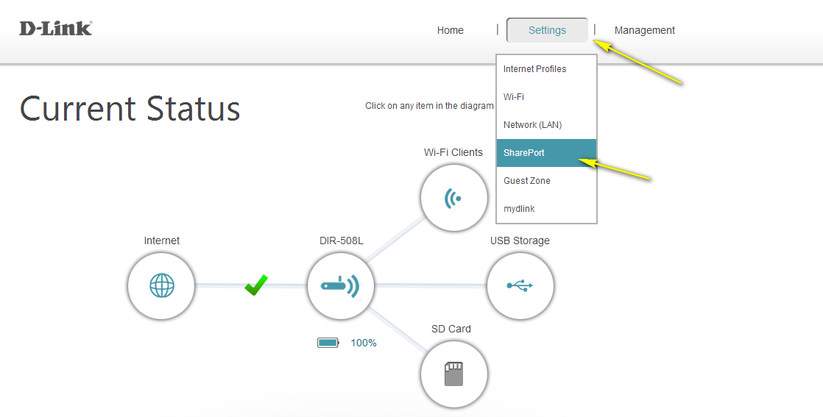

Step 4: Under DLNA Media Server, move the slider to Enabled. Under SharePort Web Access, move the slider to Enabled, and then click Save

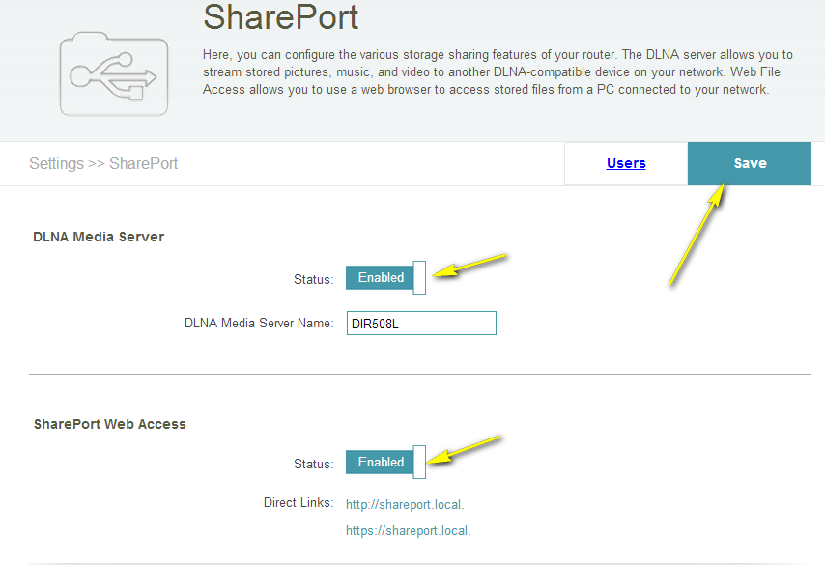

Mobile Setup

Step 5: Use your mobile device to download the mydlink SharePort™ App from the App StoreSM or Google Play®.
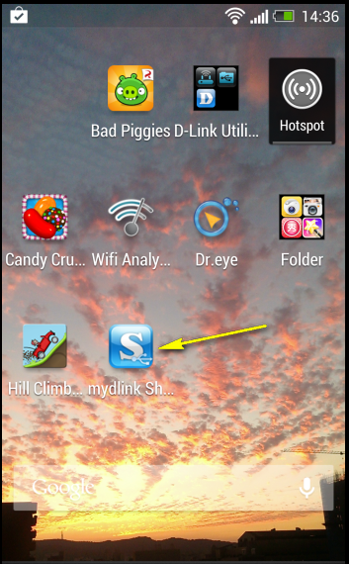

Step 7: Launch the mydlink SharePort™ App; the following screen will appear.

    - If your device is connected to your router locally, tap Local Access and enter password then tap Log in

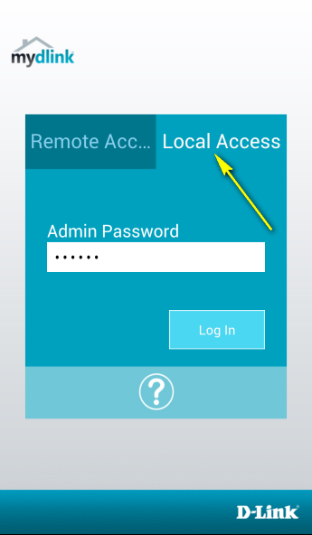

Select the file type you want to access (ie: music)
Note: If you access shareport locally, the icon at the bottom of the screen will be blue.
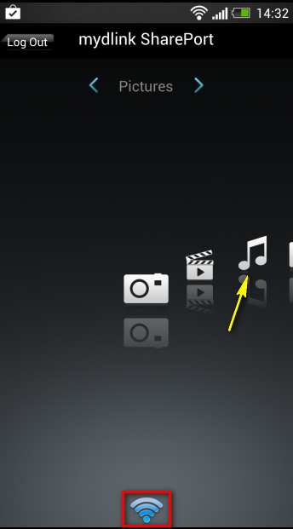

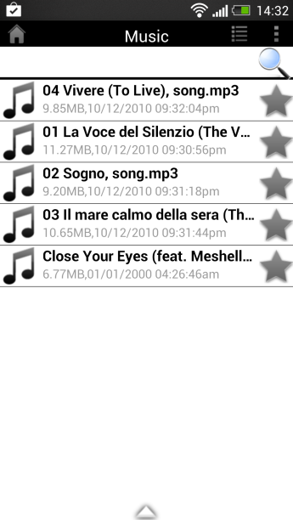

    - If your device isn’t connected to your router directly, tap Remote Access and enter your mydlink ID and password, then click Log in.

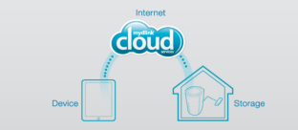
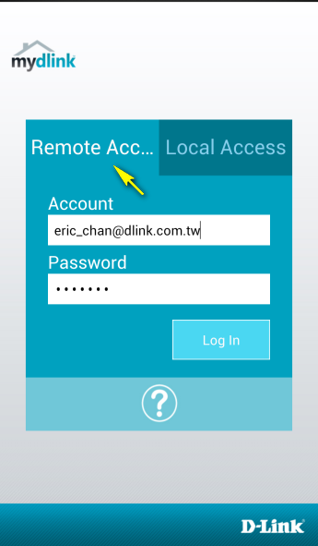

Select the router you want to access by tapping on the router name.

Select the file type you want to access (ie: music)
Note: If you access SharePort remotely, the icon at the bottom of the screen will appear green (to indicate a direct connection), or pink (to indicate a relayed connection).

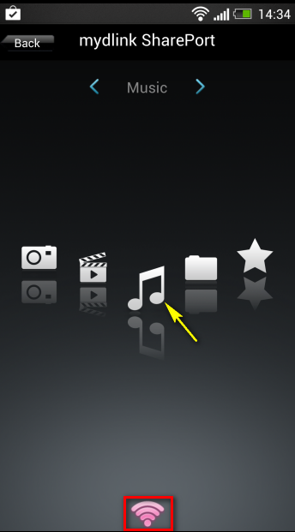

How do I configure mydlink SharePort Web Access on my router?

Step 1: Ensure your USB drive is properly connected to your DIR-508L.

Step 2: Check USB drive/SD card status using the router’s web interface.

Step 2.1: Open your web browser and enter http://dlinkrouter or http://dlinkrouter.local into the address bar.

Step 2.2: At the login page, enter the Admin Password. If you have not changed the administrator password, leave the field blank. Click Log In.

Step 2.3: Click the USB Storage icon to bring up the storage status information. Confirm that this information reflects the characteristics of the USB storage device that you have inserted into the DIR-508L’s USB port.

Step 3: Move the cursor to the Settings tab and then click SharePort.

Step 4: Under DLNA Media Server, move the slider to Enabled. Under SharePort Web Access, move the slider to Enabled, and then click Save.

Step 5: Open a new web browser and enter [IP address of your router]:[HTTP Access Port] or http://shareport.local.
Example- http://192.168.0.1:8181

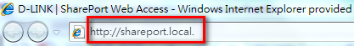

Note: If accessing from the Internet, you need to enter the router’s [WAN IP]:[Port]
Example- http://24.12.134.125:8181

Step 6: Enter your username and password
Note: By default the username is set to “admin”, and the password field should be left blank.
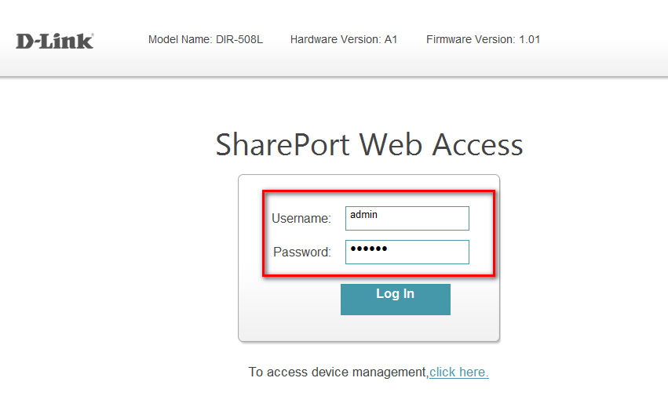

At the main menu, you can browse the files stored on your USB drive or SD card by file type.
Click the icon in the top right-hand corner (marked below by a red square) to browse by folders.
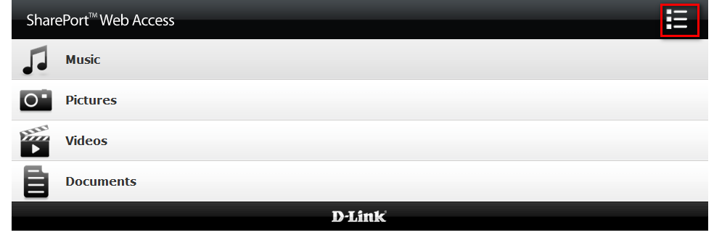

How do I change the SSID/network name of my router?

Step 1: Open your web browser and enter http://dlinkrouter or http://dlinkrouter.local into the address bar

Step 2: At the login page, enter the Admin Password. If you have not changed the administrator password, leave the field blank. Click Log In.

Step 3: Move the cursor to the Settings tab and then click Wi-Fi.
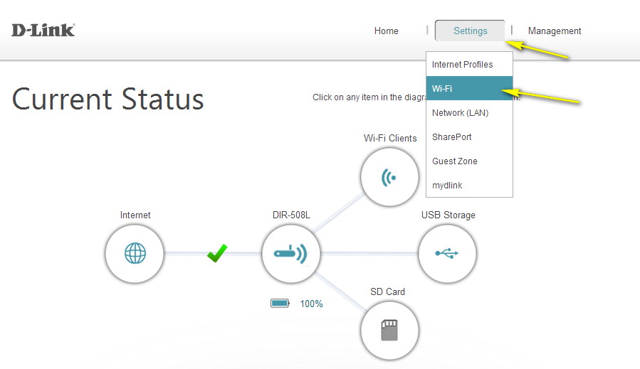

Step 4: Next to Wi-Fi Network Name (SSID), type in a new SSID. Wireless clients will need to connect to the new SSID in order to access your wireless network. This may require you to update your wireless clients’ configuration.
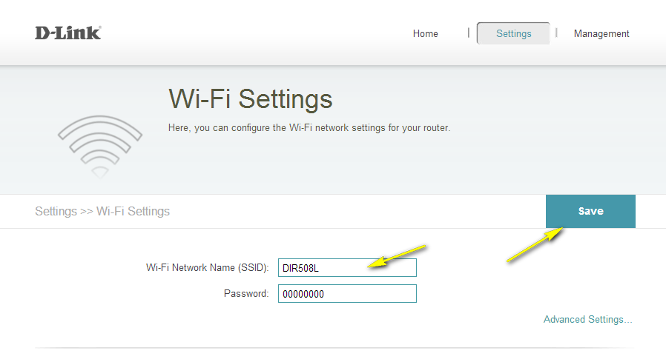
Step 5: Click Save.

How do I change the Wi-Fi password on my router?

Step 1: Open your web browser and enter http://dlinkrouter or http://dlinkrouter.local into the address bar

Step 2: At the login page, enter the Admin Password. If you have not changed the administrator password, leave the field blank. Click Log In.

Step 3: Move the cursor to the Settings tab and then click Wi-Fi.

Step 4: In the Password field, specify the new wireless password. Wireless clients will need this password in order to access your wireless network. This may require you to update your wireless clients’ configuration. 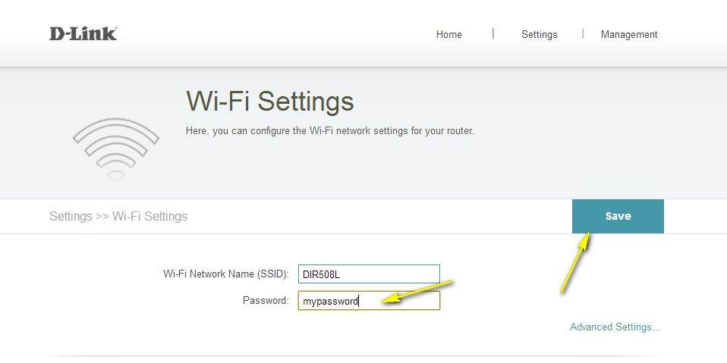
Step 5: Click Save.

How do I upgrade the firmware on my router?

Step 1: Open your web browser and enter http://dlinkrouter or http://dlinkrouter.local into the address bar

Step 2: At the login page, enter the Admin Password. If you have not changed the administrator password, leave the field blank. Click Log In.

Step 3: Move the cursor to the Management tab and then click Upgrade.
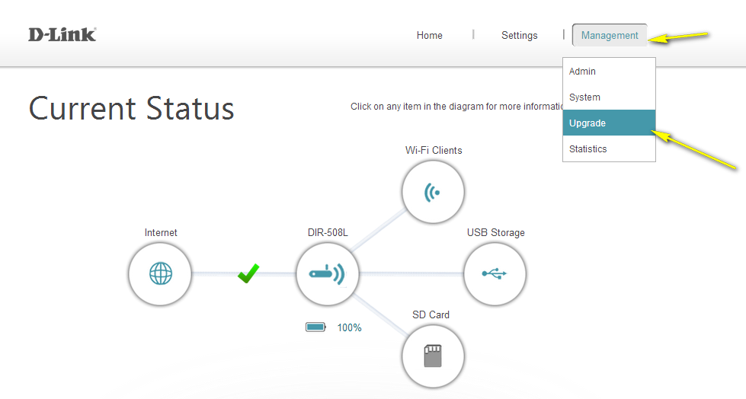

Step 4: Click the Check For New Firmware button. If the DIR-508L finds new firmware, then the firmware will be upgraded automatically.
Warning: No not turn off your router during the firmware upgrade process. It is also recommended that you only conduct a firmware upgrade when the device is connected to the AC power adapter.

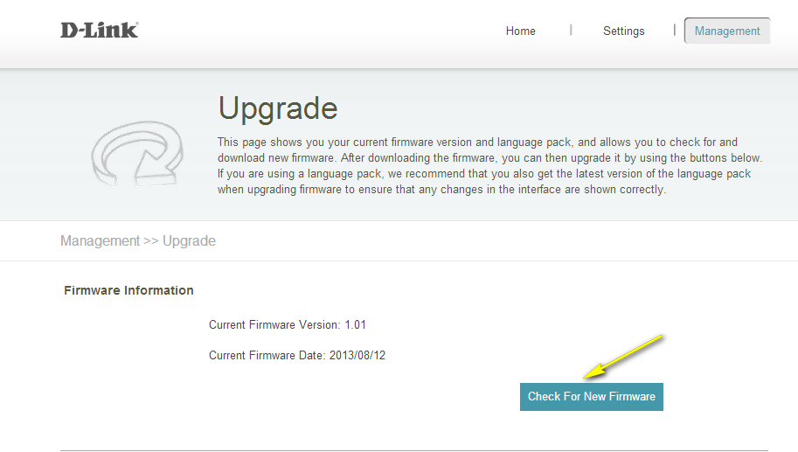

How do I charge other devices using my DIR-508L?

The DIR-508L can be used as a portable charger to recharge your mobile devices on the go, including high-powered devices such as iPads.
Step 1: Slide the ON/OFF/CHARGER switch of the DIR-508L to CHARGER.

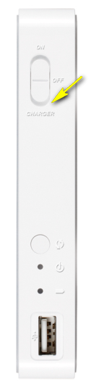

Step 2: Plug your device into the USB port of the DIR-508L. Check your device to make sure it is now charging.
Note: If the battery LED is red, you will need to charge the DIR-508L. Actual usable capacity may vary depending on charging conditions.

How do I back up the router’s configuration to my computer?

Step 1: Open your web browser and enter http://dlinkrouter or http://dlinkrouter.local into the address bar

Step 2: At the login page, enter the Admin Password. If you have not changed the administrator password, leave the field blank. Click Log In.

Step 3: Move cursor to the Management tab and then click system.
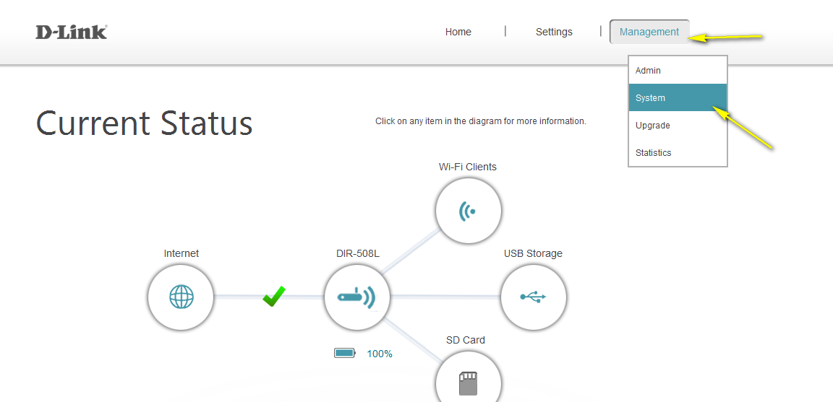

Step 4: Click Save the Settings To File.
Note: Depending on your browser, a ‘File Download’ dialog may appear, allowing you to select a location and file name for the settings file. The file may also be automatically saved to your default ‘Downloads’ folder.
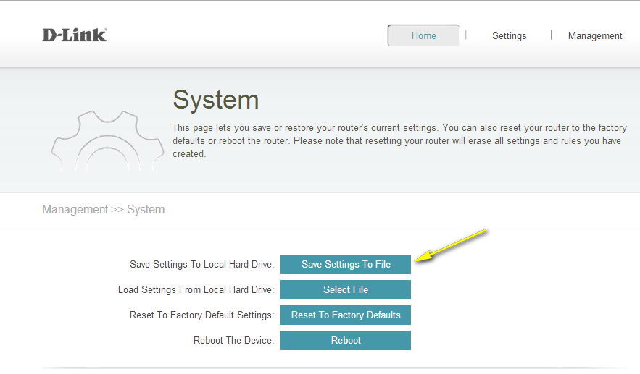

How many simultaneous users can my Wi-Fi network handle?

The number of connected users will affect data transfer speeds. It is recommended that no more than 15 users are connected to the DIR-508L simultaneously, in order to avoid a reduction in connection and speed performance.

How do I connect my laptop to my wireless router?

Step 1: Click on the network icon in the bottom right corner (next to the clock)
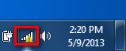

Step 2: Select the wireless network you want to connect to and click Connect.
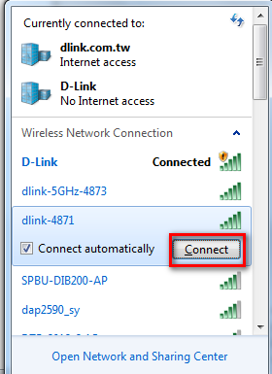

Step 3: If you have a Wi-Fi password configured on your router, enter the password and click OK.
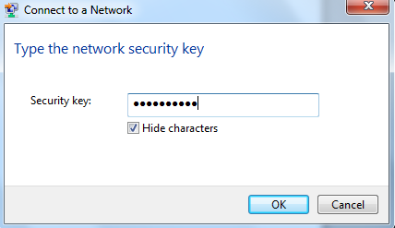
Step 4: Select the Network Location type.
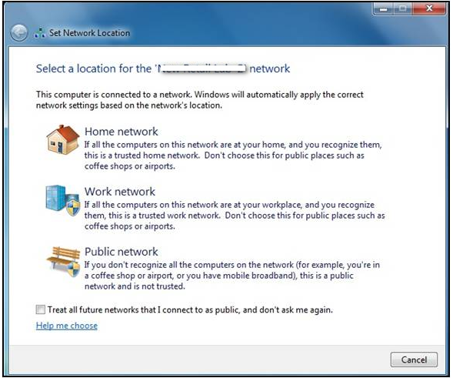

Step 5: Your computer should now be connected to the wireless network. This will be confirmed in the Wireless Network Connection window.
